Nepal College of Information Technology
Assessment
Fall 2011

Level: Bachelor |  |  | Year : 2011
Programme: CE/ELX/IT-III |  |  | Full Marks: 100
Course: Logic Circuits |  |  | Time : 3hrs.
Attempt all the questions.
 | - Use r’s complement to subtract the following  - (00011000)₂ – (00000110)₂  - (835701)₁₀ - (956821)₁₀  - Construct X-NOR gate using minimum number of NAND gates only.  - Realize NOT, AND and OR gates by NOR gates only. |  |  |  |  | 5  5  5
 | a) Use K-map to simplify:  F(A,B,C,D)= Σ (5,7,9,12,13,14,15) &  D(A,B,C,D)= Σ (3,6,8) in POS form and implement the simplified function using NOR gate only.  b) Design a full adder ckt using two 4:1 MUX. |  |  |  |  | 7  8
 | Design a BCD to seven segment decoder |  |  |  |  | 15
 | a) Design a BCD adder which gives BCD sum when two 4-bit binary numbers are given as an i/p  b) What are the steps involved in a sequential ckt design. |  |  |  |  | 9  6
 | - Design a combinational circuit to check for even parity of 4 bits. A logic-1 is required when the 4-bits do not constitute an odd parity.  - A combinational circuit is defined by  F1(A,B,C)= Σ (0,1,2,4)  F2(A,B,C)= Σ (1,3,5,6)  Derive a PLA program table with minimum no. of product terms. |  |  |  |  | 7  8
 | - Explain the operation of clocked R-S flip-flop with the help of its logic diagram and characteristic table. Mention the drawback of this flip-flop. Write down the characteristic eq^{n} and graphic symbol for the same.  - Realize the following state diagram into the circuit using D-flip-flop.  0/0  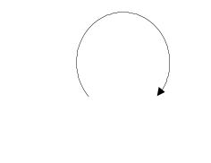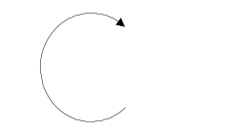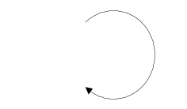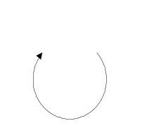  0/0  00  10  1/0  1/0  01  11  1/0  1/1  0/0  0/0 |  |  |  |  | 7  8
 | Write short notes on (Any Two) :  - ROM and its types  - Priority Encoder  - Master-Slave flip-flop |  |  |  |  | 5×2

